**Experiment Title – 3.1**

**Student Name:** YANA SRIVASTAVA **UID:** 20BCS2279

**Branch:** BE-CSE **Section/Group:** 20BCS-WM-906/B

**Semester:** 5th  **Subject Code:** 21 CSP-321

**Subject Name:** PBLJ LAB

**1. Aim:** Create a palindrome creator application for making a longest possible palindrome out of given input string.

**2. Software/Hardware Requirements:** VS Code or Eclipse

**3. Algorithm/ PsuedoCode:**

STEP 1: Create a index.jsp file in a webapp directory.

STEP 2: Create a package named as fun and create a java file named as functions.java.

STEP 3: functions.java file contains the logic for checking the palindromic substring.

STEP 4: At Last start the server and display the output on the web browser.

STEP 5: EXIT.

**CODE:**

***Index.jsp***

<%@ page language=*"java"* contentType=*"text/html; charset=ISO-8859-1"*

pageEncoding=*"ISO-8859-1"*%>

<!DOCTYPE html>

<html>

<head>

<meta charset=*"ISO-8859-1"*>

<title>Insert title here</title>

<style>

**body**{

background: *linear-gradient(45deg, red, blue)*;

backgroung-size: *cover*;

color: *white*;

align-items: *center*;

}

**h1**{

text-align:*center*;

}

*.fall*{

border: *2px solid orange*;background: *blue*;

padding: *5px*;

max-width: *500px*;

height: *100px*;

margin: *auto*;

font-size: *19px*;

}

**input**{

width: *250px*;

}

**button**{

position: *relative*;

left: *170px*;

margin: *10px*; width: *60px*;height:*30px*;

cursor:*pointer*;border-radius:*5px*;

}

**button***:hover*{

color:*white*;

background: *black*;

}

</style>

</head>

<body>

<h1>find the Longest Palindromic Substring</h1>

<form class=*"fall"* name=*"funcitons"* action=*"*<%=request.getContextPath()%>*/functions"* method=*"post"*>

Enter the Palindromic String: <input class=*"check"* type=*"text"* name=*"pal"* size=*"50"*><br>

<button type=*"submit"*>Submit</button>

<button type=*"reset"*>Reset</button>

</form>

<h1> longest Palindromic SubString <br/> <%=request.getAttribute("ans") %></h1>

</body>

</html>

***Functions.java***

package fun;

import java.io.IOException;

import javax.servlet.ServletException;

import javax.servlet.annotation.WebServlet;

import javax.servlet.http.HttpServlet;

import javax.servlet.http.HttpServletRequest;

import javax.servlet.http.HttpServletResponse;

/**

* Servlet implementation class functions

*/

@WebServlet(name="functions",urlPatterns={"/functions"})

public class functions extends HttpServlet {

protected void doPost(HttpServletRequest request, HttpServletResponse response) throws ServletException, IOException {

String a=request.getParameter("pal");

// String fun=request.getParameter("fun");

try {

// System.out.println(a+fun);

int n=a.length();

String ans;

if(n<=1) {

ans=a;

request.setAttribute("ans",ans);

request.getRequestDispatcher("index.jsp").forward(request,response);

}

else {

int len=1,s=0;

int low,high;

for(int i=1;i<n;i++) {

low=i-1;

high=i+1;

while(high<n&&a.charAt(high)==a.charAt(i)) {

high++;

}

while(high<n&&a.charAt(low)==a.charAt(i)) {

low++;

}

while(low>=0 && high<n && a.charAt(low)==a.charAt(high)) {

low--;

high++;

}

int length=high-low-1;

if(len<length) {

len=length;

s=low+1;

}

}

ans=a.substring(s,s+len);

request.setAttribute("ans",ans);

request.getRequestDispatcher("index.jsp").forward(request,response);

}

}catch(Exception e) {

System.out.println(e);

}

}

}

***OUTPUT:***

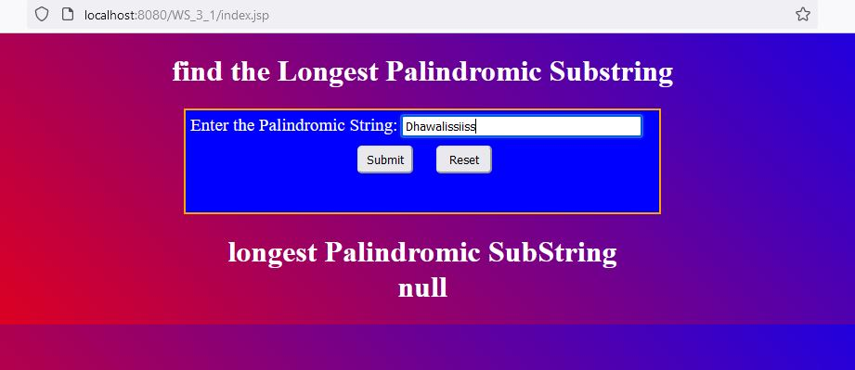

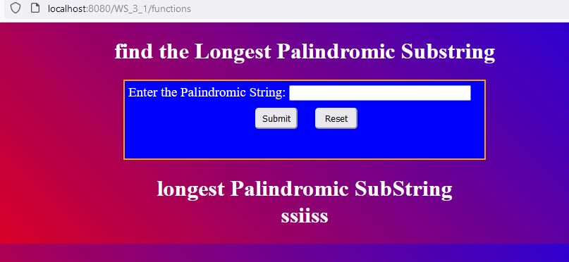

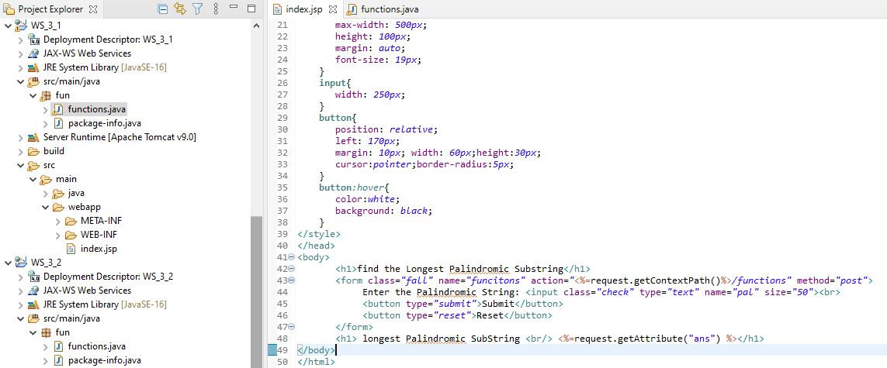

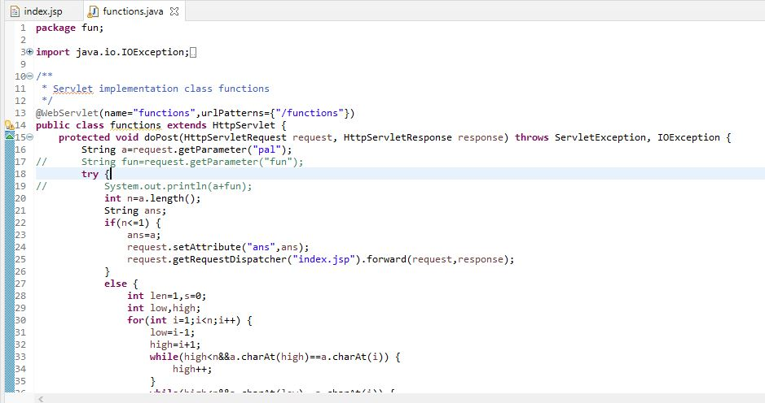

**Learning outcomes (What I have learnt):**

1. Learn About the servlet.
2. Learn about jsp and dynamic web project.
3. Learn about the tomcat server and its integrations with the java.